

MICROSTRATEGY

Version 0.1

STEPS TO CREATE DASHBOARD

Prepared For: DATA MANAGEMENT TEAM

Prepared By: HARKIRAT GHOTRA (CO-OP STUDENT)

Date: 2016-05

**Table of Contents**

1. Steps for creating dashboard in Desktop 3

2. Steps for creating “IC_NETEZZA_PERFORMANCE” 4

3. Selector 13

4. Steps to create second page of dashboard 16

1. **Start with dashboard in Micro Strategy Desktop**

* Just go to report folder, then right click on screen and go to new and click on document
* After that click on dashboard and then select a report and then an empty dashboard will pop up.
* These steps, I have already shown in “Microstrategy.doc”. If find confusion, follow the screen shot in that document.

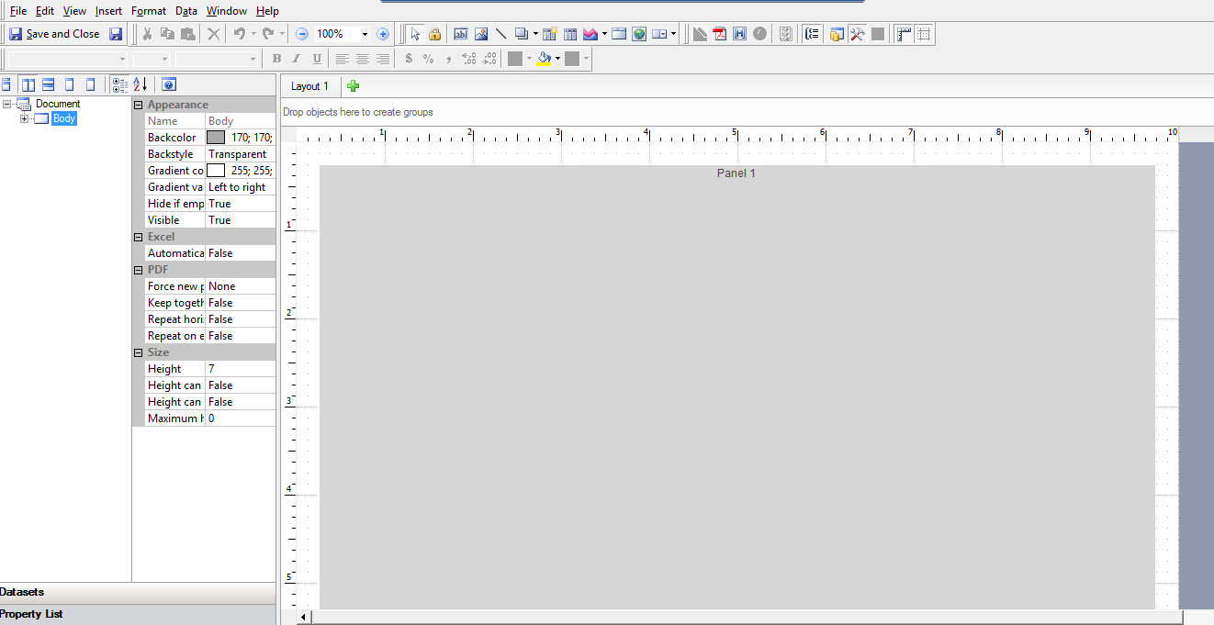

* **Different functions inside dashboard**

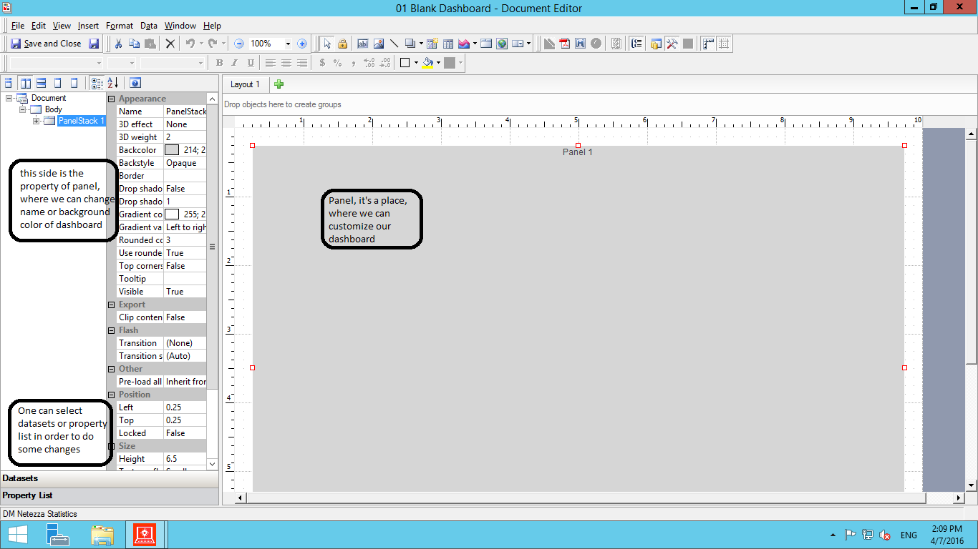

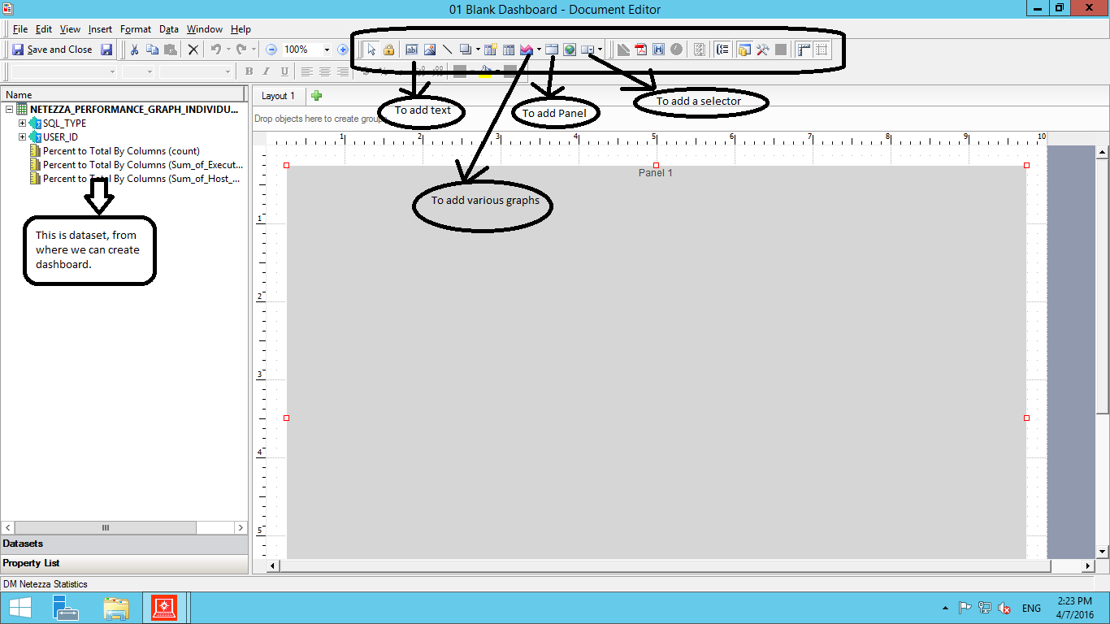

1. **Steps to follow for dashboard “IC_NETEZZA_PERFORMANCE”**

* Open the new dashboard in report folder.
* First select the report i.e” QUERY_SUMMARY_LAST_10_MINUTS”
* When dashboard will open, just delete the panel and try to add your own panel.



* After that just add another panel and change the name of respective panel by clicking on “property list”

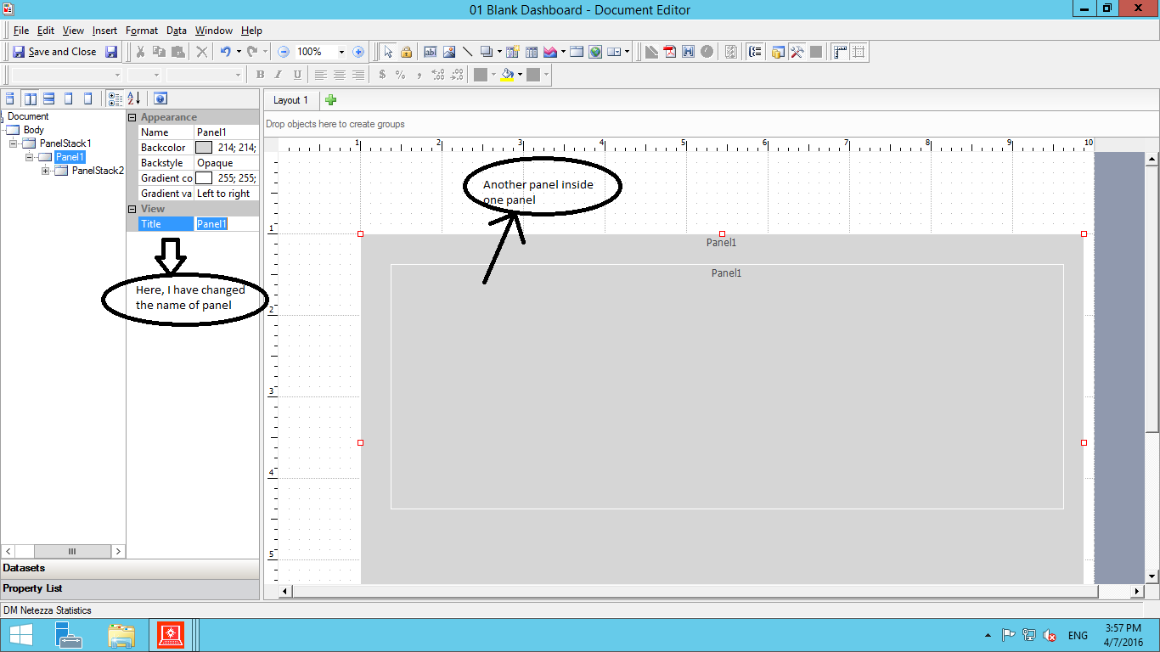

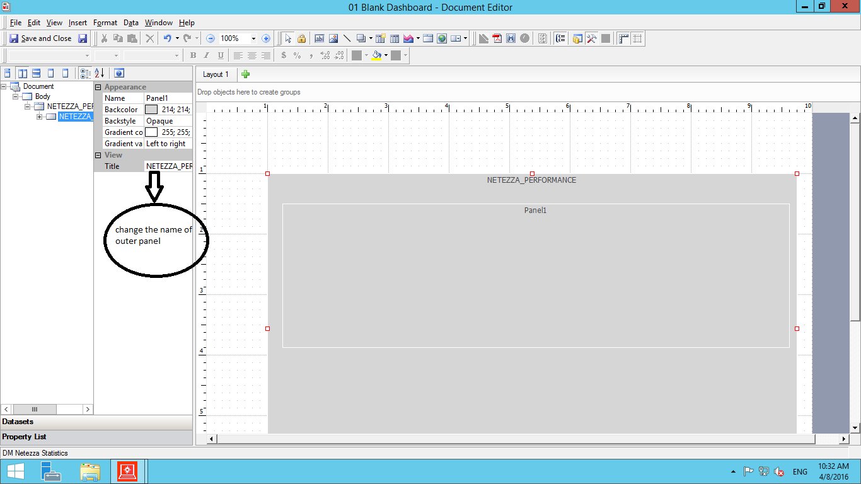

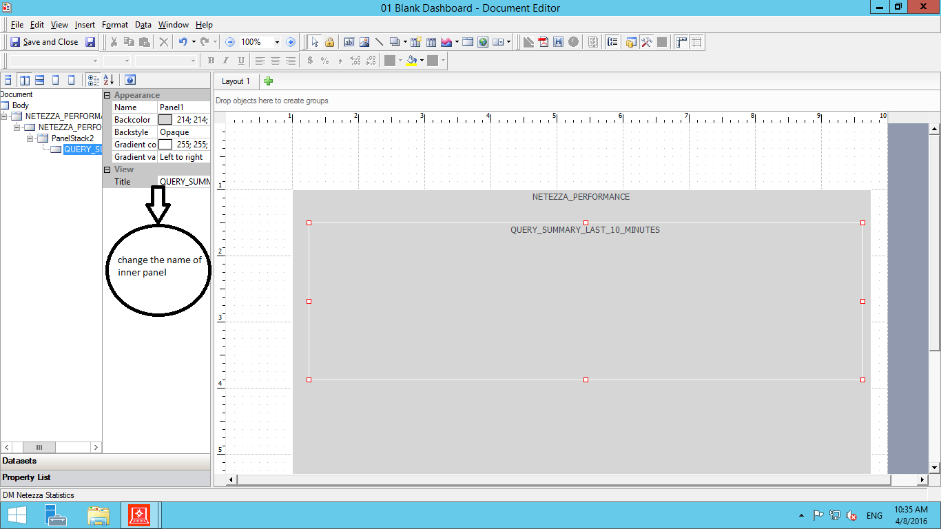

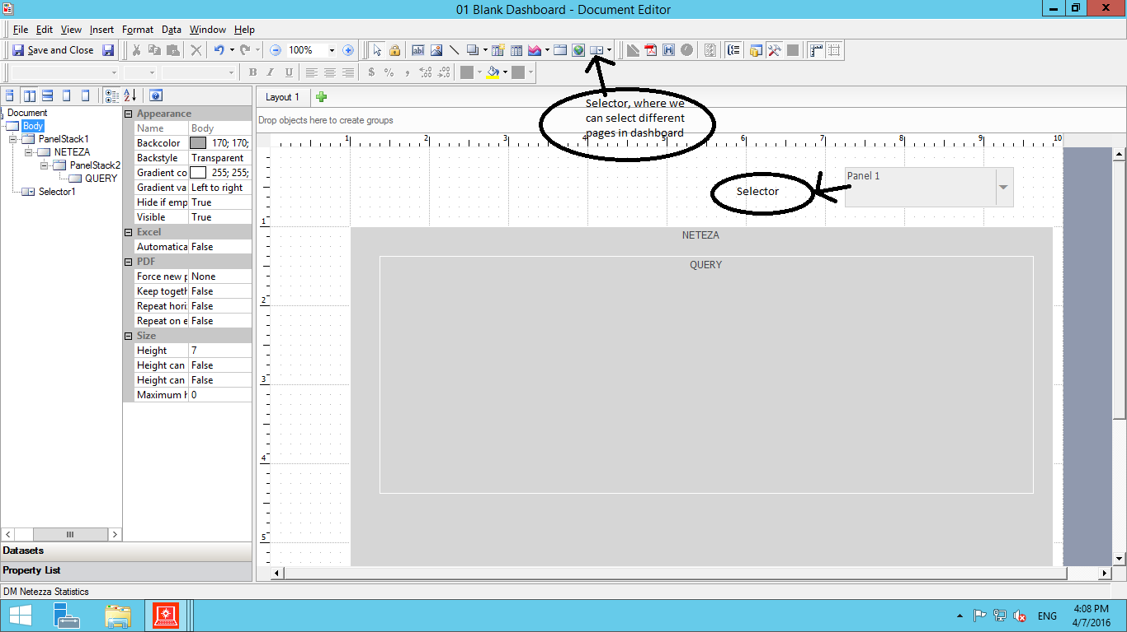

* Just select graph from tool and then select horizontal bar graph and drop the attribute and metrics into respective column.

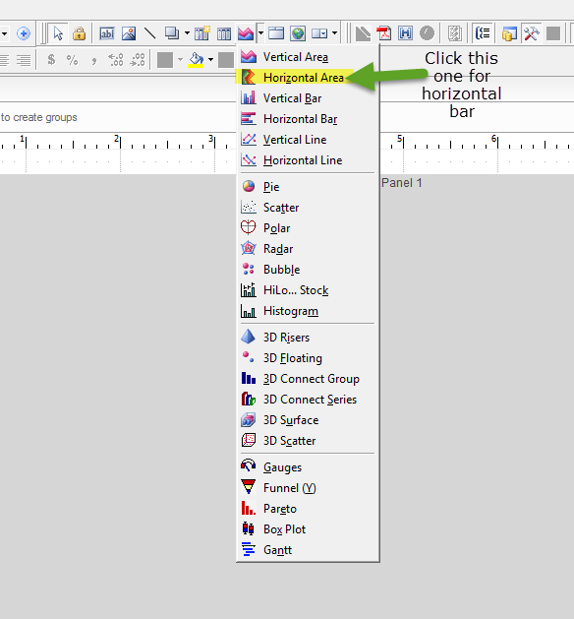

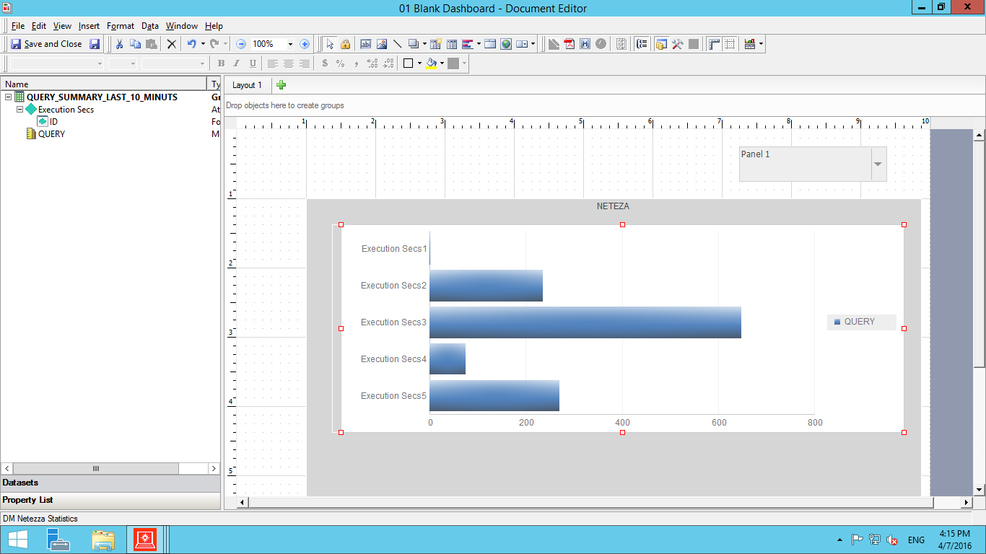

* Just save the work on dashboard and see whether dashboard looks good or not.
* Open the Web Micro Strategy, go-> shared report and then click on dashboard. It will run the dashboard and we can see how our dashboard looks like.
* Whenever, you add any graph, always check how it looks like in Micro Strategy Web.
* Now just add another panel under first one.

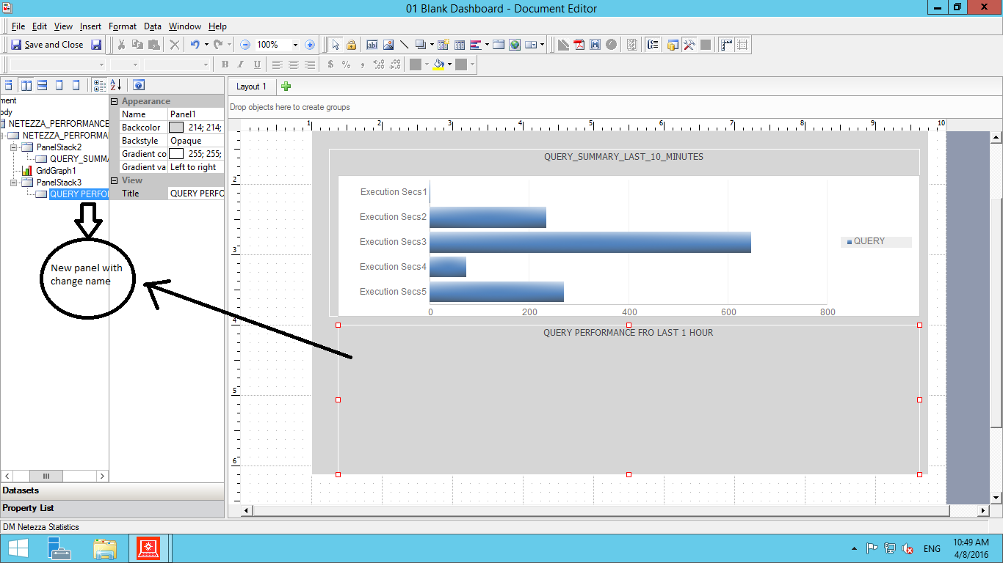

* After that just add another dataset that is “PERFORMANCE FOR LAST 1 HOUR”
* For adding any dataset in dashboard, always use Micro Strategy Web because I could not find option in Micro Strategy desktop to add any dataset.
* Just open link in web browser (<http://microstrategydev.cgic.ca/MicroStrategy/ASP/Main.aspx>)
* Then it will ask for user id and password, then the page will open which display all the project but we have to choose our project that is (“DW NETEZZA STASTISTICS”).
* After that our project home screen will open.

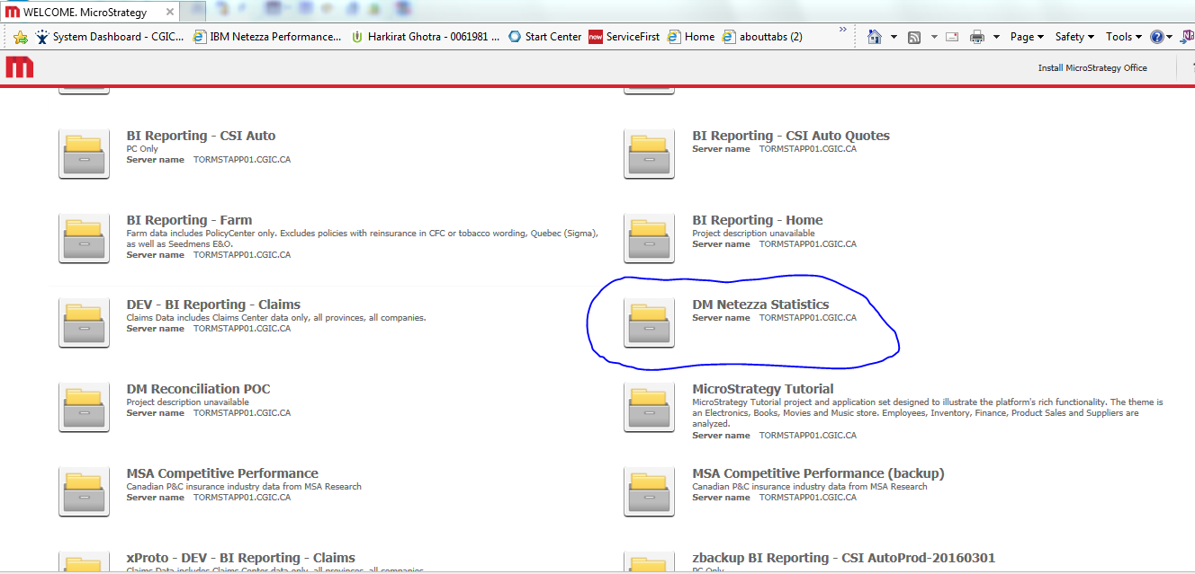

* Just click on shared report and then click on document (“DW NETEZZA STATISTICS”) and our dashboard run.

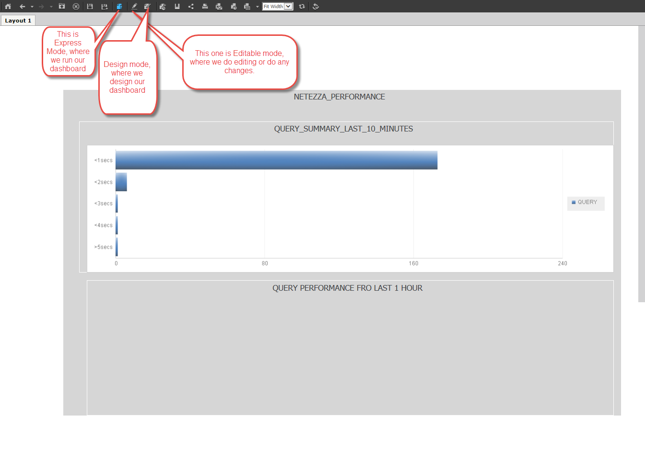

* Click on edit button and then we can edit dashboard.

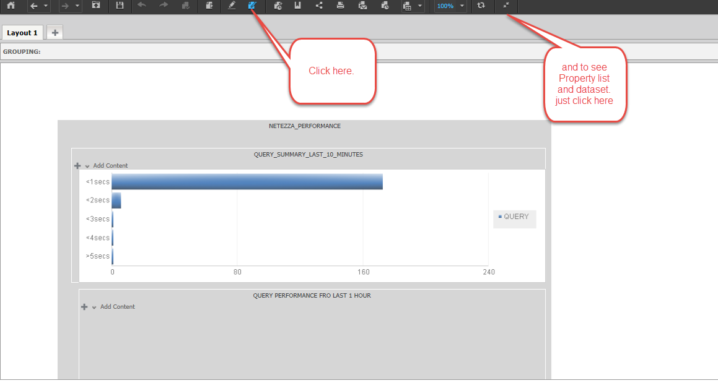

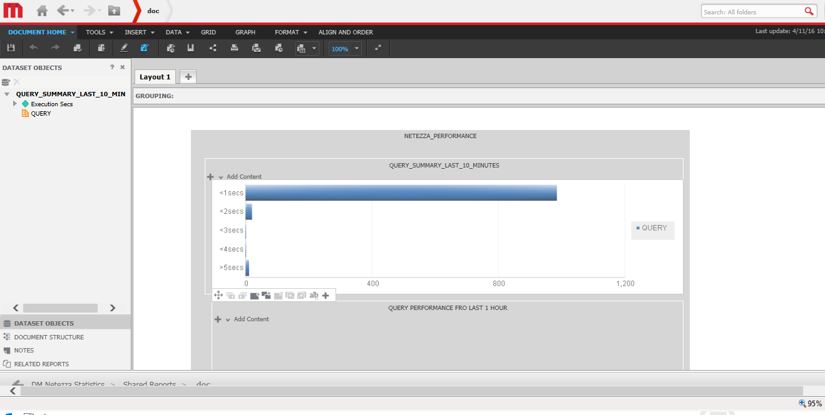

* Then add another dataset, which is “PERFORMANCE FOR LAST 1 HOUR” and do the same step which we did for “QUERY_SUMMARY_FOR_LAST_10_MINUTS”.

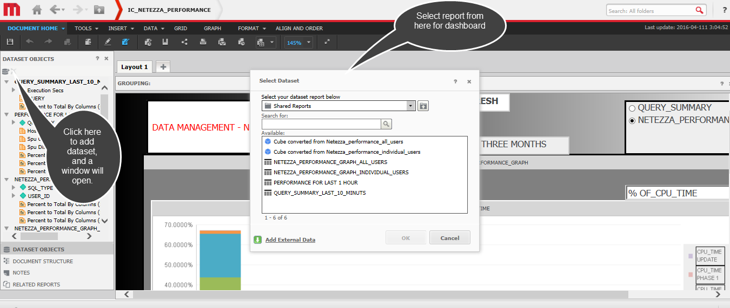

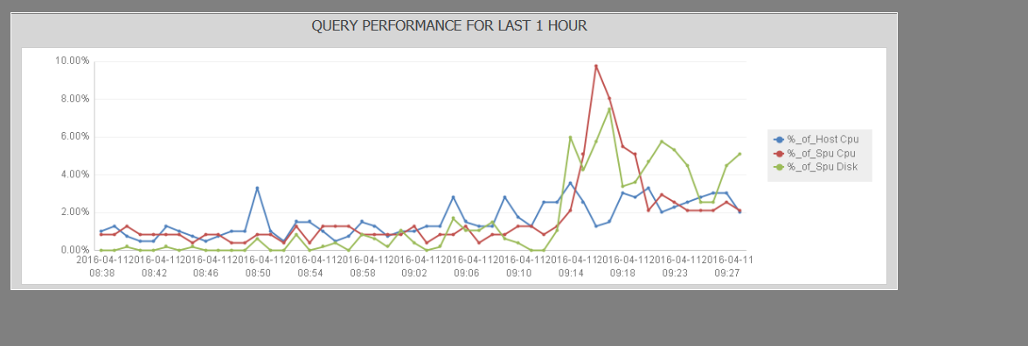

* Once, we got our first page, we can add more pages by using selectors.
* Then, just move back to desktop developer tool, edit the dashboard in report folder.
* Then duplicate the first page and change the dataset of that page in Micro Strategy Web

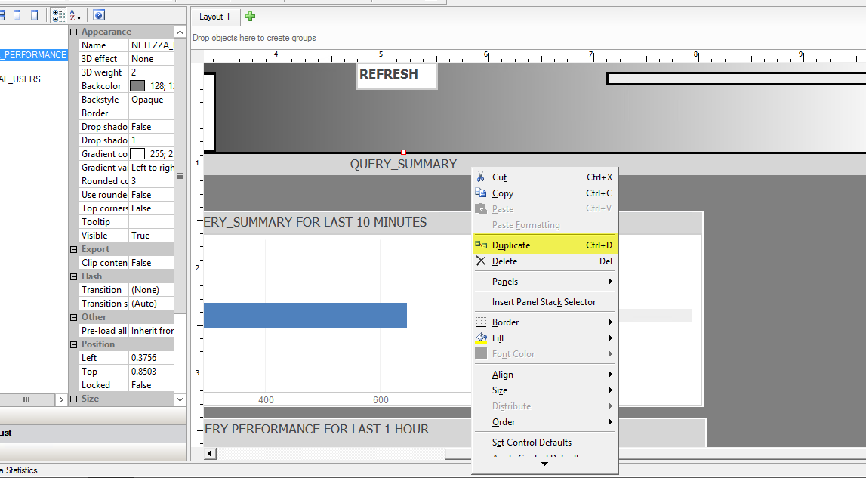

1. **Selector**

* I have used selector, so that we can shuffle from different pages.

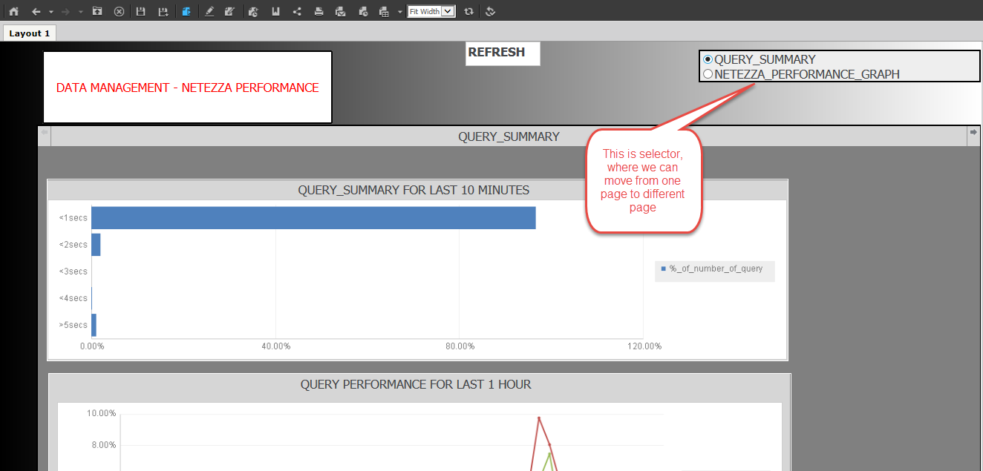

1. **Steps to add selector option with property setting**

* Just go to Micro Strategy desktop, then select the selector and then you can draw selector anywhere.

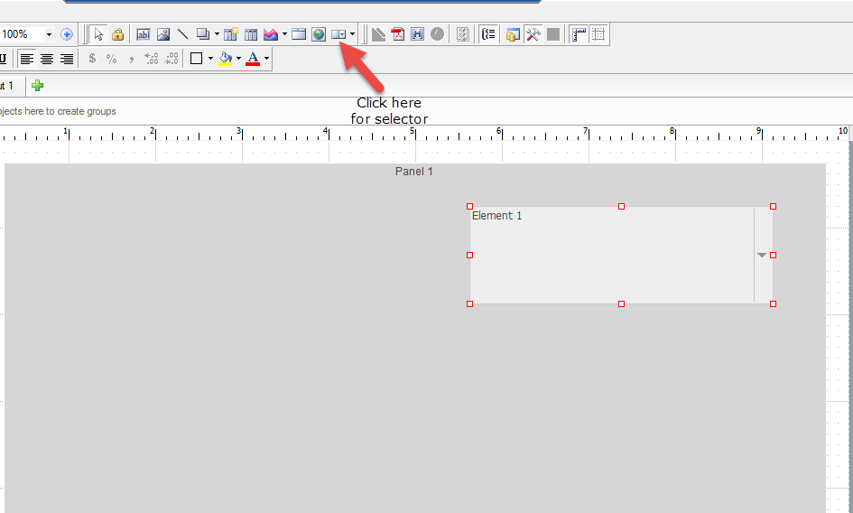

* After that right click on selector-> go to property and then select Selector option from the top. Then change the Action type to “select panel”, after that select panel stack from last option.

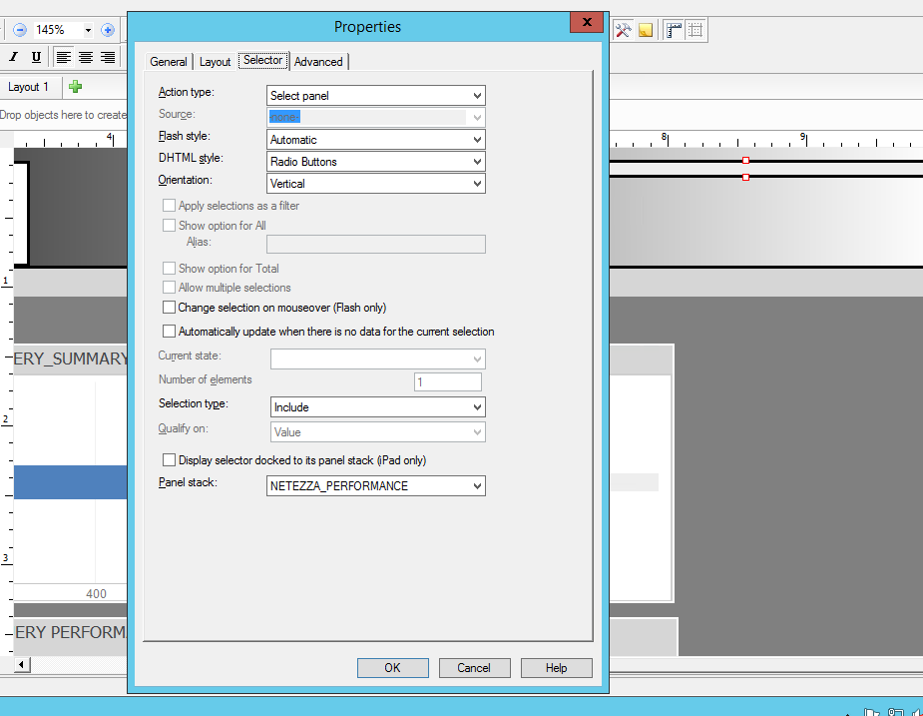

* Now, just move to another duplicate page and start dragging and dropping attributes and facts from different datasets.

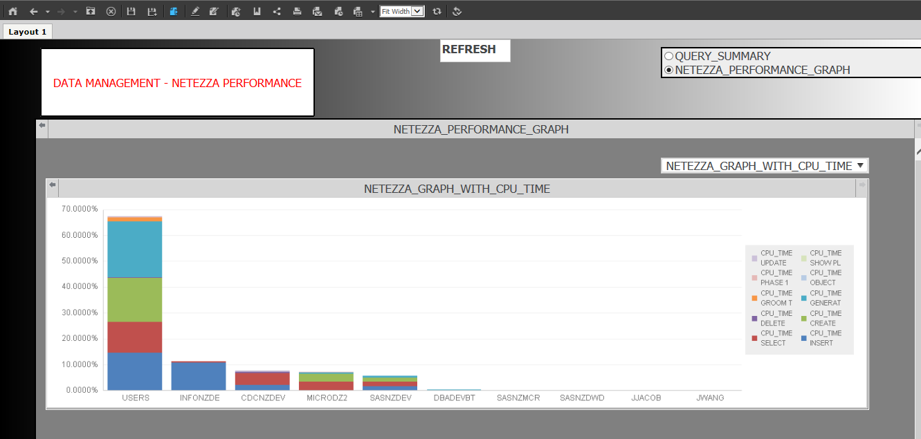

1. **Steps to create second page**

* Just follow the same steps, add the datasets “NETEZZA_PERFORMANCE_GRAPH_ALL_USERS” and “NETEZZA_PERFORMANCE_GRAPH_INDIVIDUAL_USERS”. First dataset shows all the users and another one is showing all individual users other than system users. The output is from Dev box.
* Once you add the datasets, then just go to those page in Micro Strategy desktop and then right click on the panel and click panel and then manage, you will see a properties box and then name them differently. You need three panels in second page, because I have used selector in second page, which changes the graph according to selection.
* After that, click on the selector option and drop and drag above first panel.

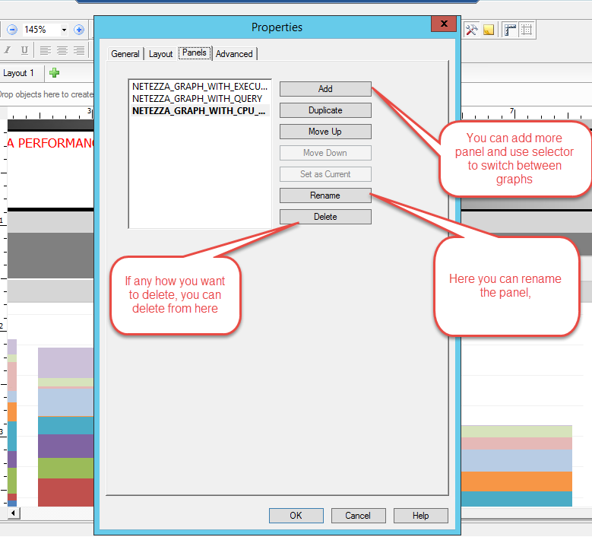

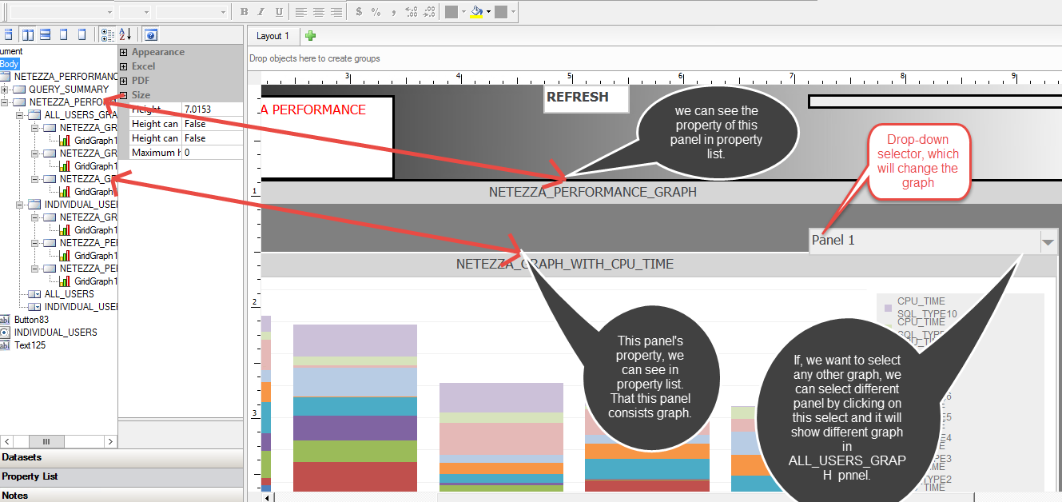

1. **Selector setting of above panel**

* Just right click on selector and then go to property, the properties window pop up.
* Then go to selector, select “select panel” in Action Type and DHTML Style to drop-down and also select “ALL_USERS_GRAPH” in panel stack.

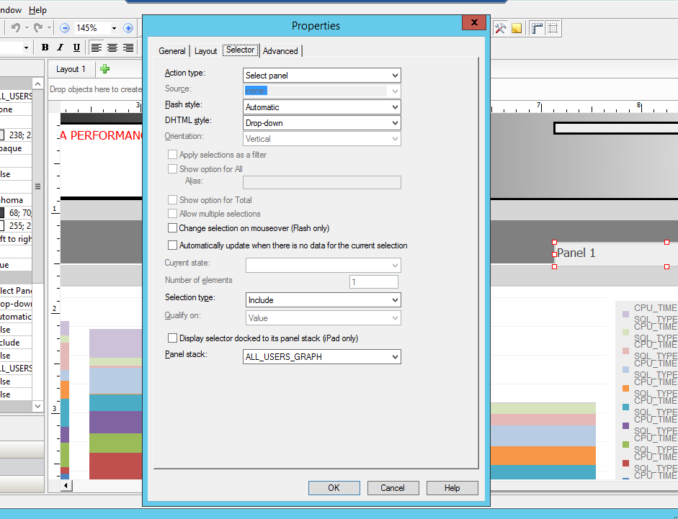

* Do same with another graph which is below this one. That graph shows all the individual users other than system users under different directors.
* Again right click on lower panel and then select panel option then go to manage. Name each three panel differently and drop and drag the selector above lower panel.

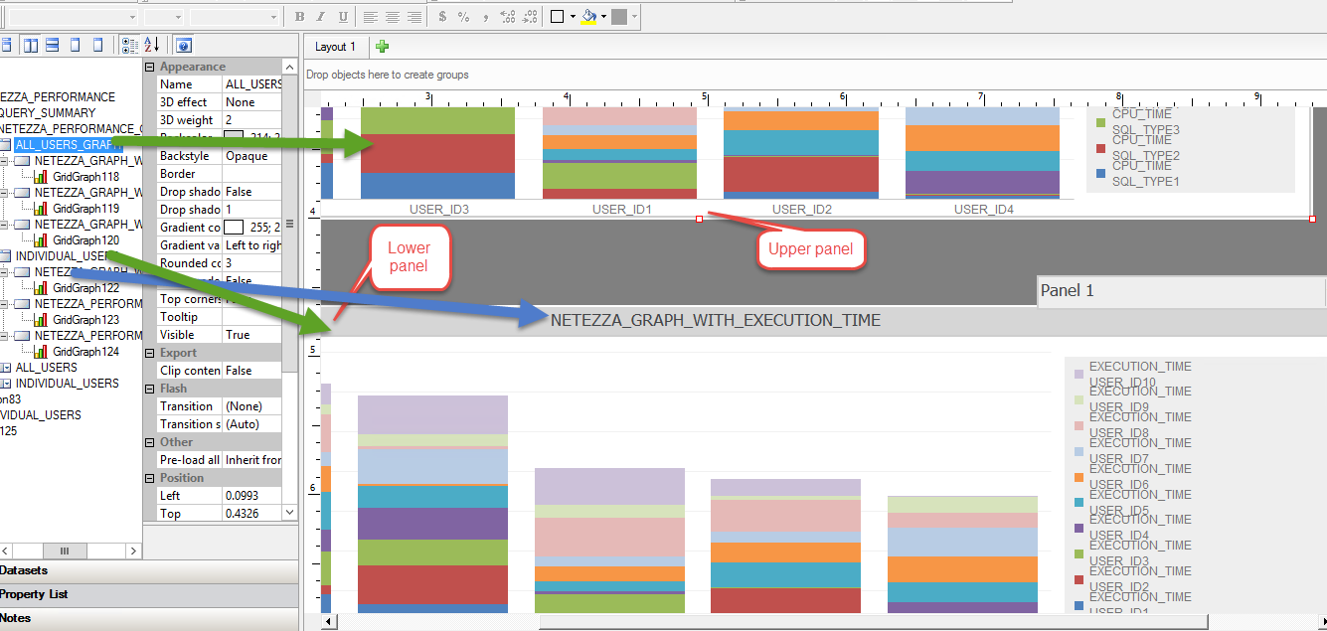

1. **Selector setting of lower panel**

* Just right click on selector then go to properties and then click on selector.
* After that just choose “select panel” in Action type and DHTML style is drop-down.
* Select the particular panel name in panel stack. Like we have “ALL_USER_GRAPH” for above panel. For lower panel just select “INDIVIDUAL_GRAPH”

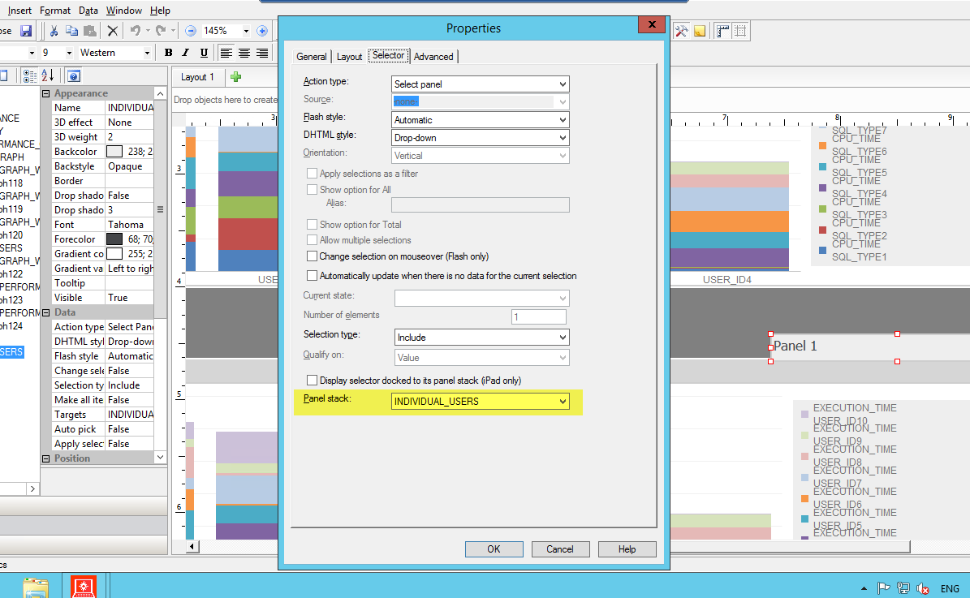

1. **Steps to create graphs for second page.**

* Go to the Micro Strategy Web, then go to shared report, open the dashboard (“IC_NETEZZA_PERFORMANCE”).

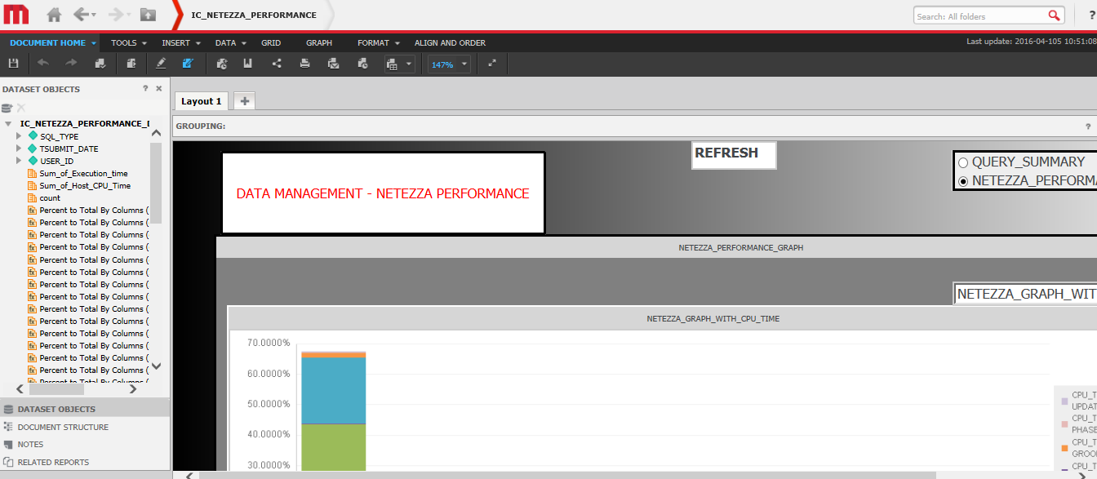

* This is the editable mode, where we can add dataset. For, above panel, first select “NETEZZA_GRAPH_WITH_EXECUTION_TIME” through selector.

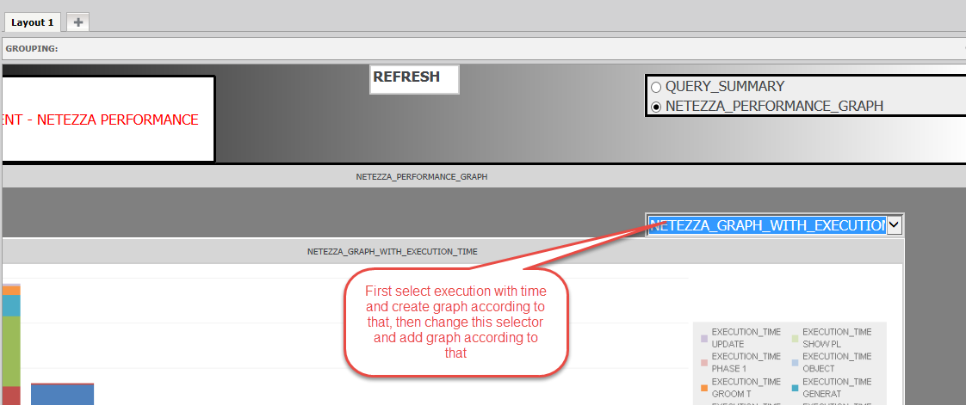

* After that, just add dataset from shared report. So, for above panel, we can add “NETEZZA_PERFORMANCE_GRAPH_ALL_USERS”.

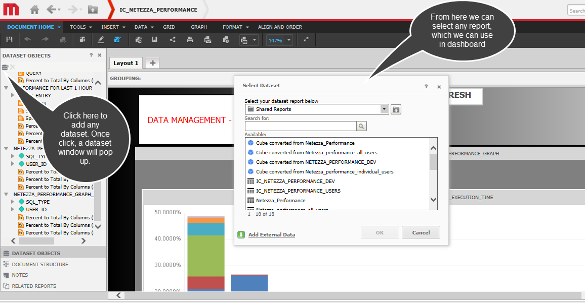

* After that click on “Add Content”, which will show different options and then select “graph”.

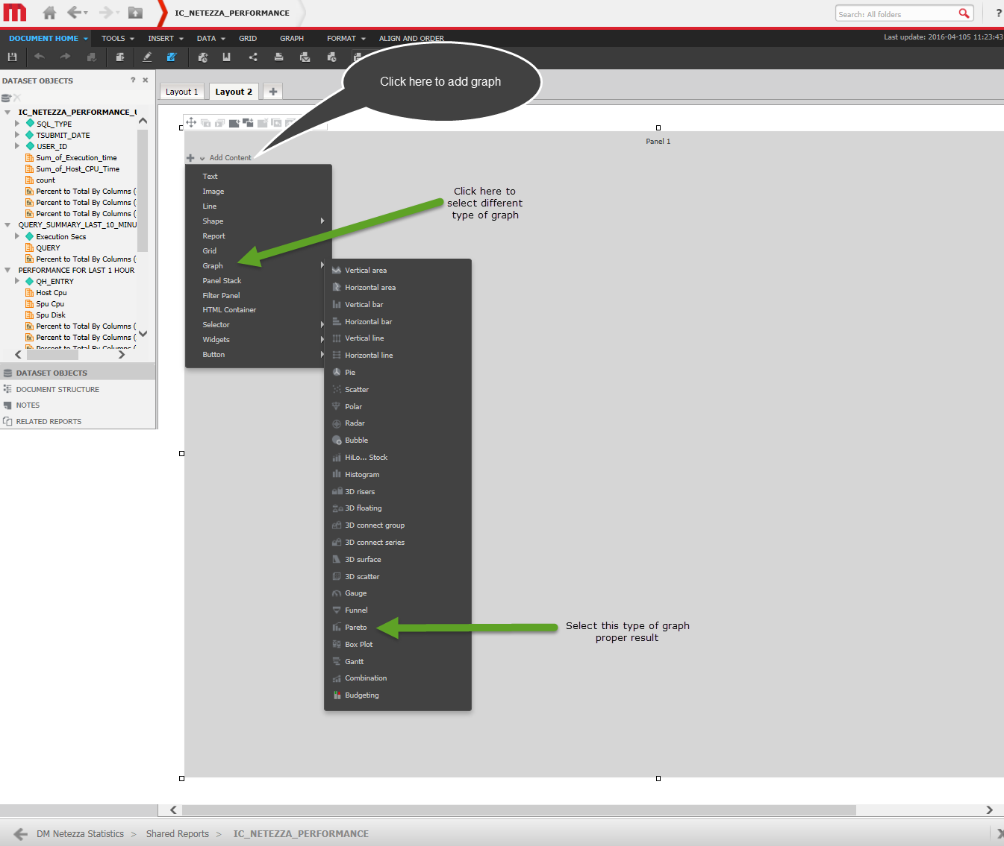

* After selecting “Pareto” type of graph, just drop and drag USER_ID from dataset in categories and SQL_TYPE in series and in metrics just add Percent to total by column (sum_of_execution_time). This will give you one graph with execution time.

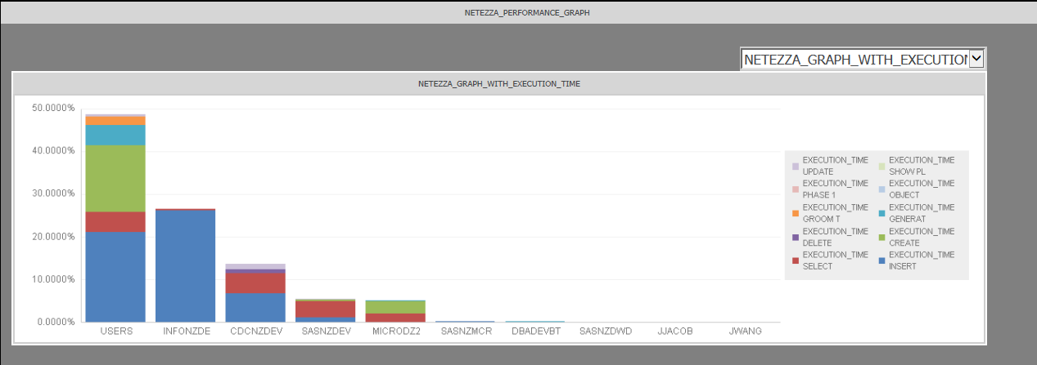

* Again change the selector, “NETEZZA_GRAPH_WITH_CPU_TYPE” and then click on “Add Content” then do the same step. Just we need to add “Percentage to total by column (sum_of_cpu_time).
* Do same with “NETEZZA_GRAPH_WITH_QUERY”.
* Then, we can see all the three graph with the help of selector.
* Now, for lower panel, do the same. Add different dataset from shared report that is “ NETEZZA_PERFORMANCE_GRAPH_INDIVIUAL_USERS” and repeat the same step to create a graph

1. **Adding text and labels**

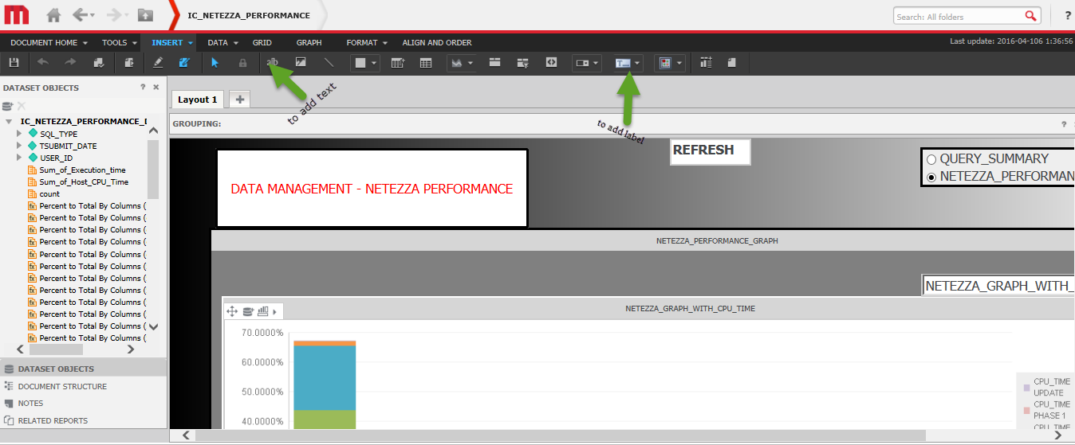

* There is also a refresh button, which will refresh the page. Just right click the refresh button then go to edit link then a new window will show.

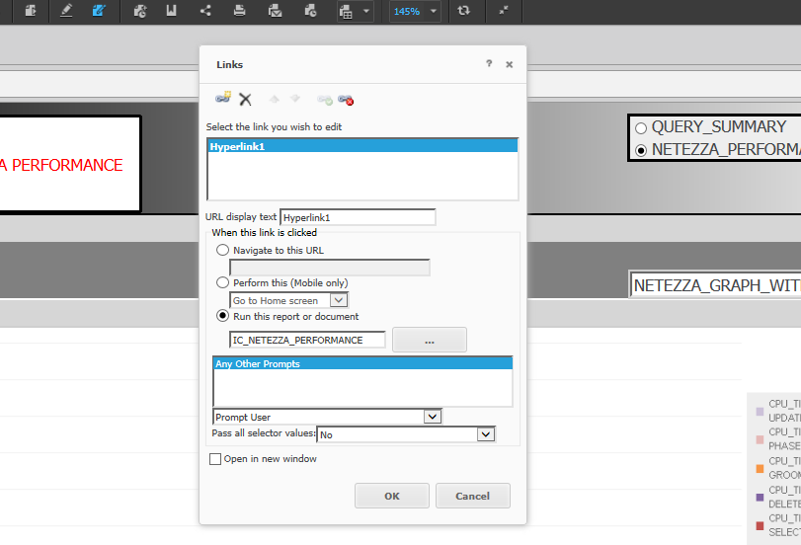

* Just check the “run this report or document” option and click on ok button.
* Now, we have our full view of dashboard.

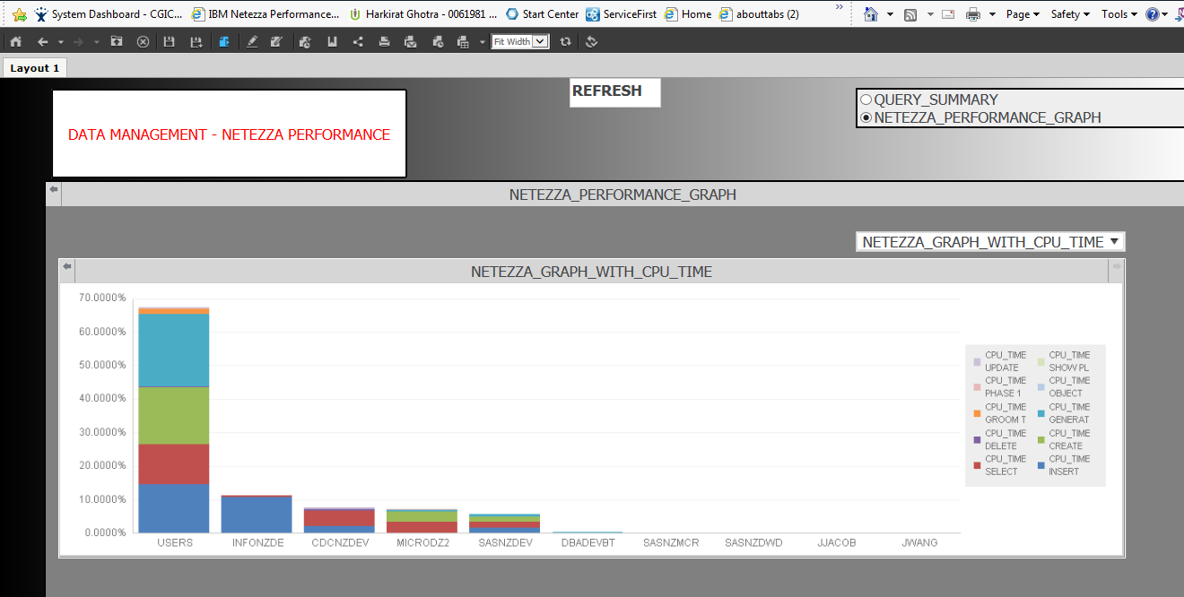

Thank you

Harkirat Ghotra